**How Innovative Web Design Can Transform Your Business**

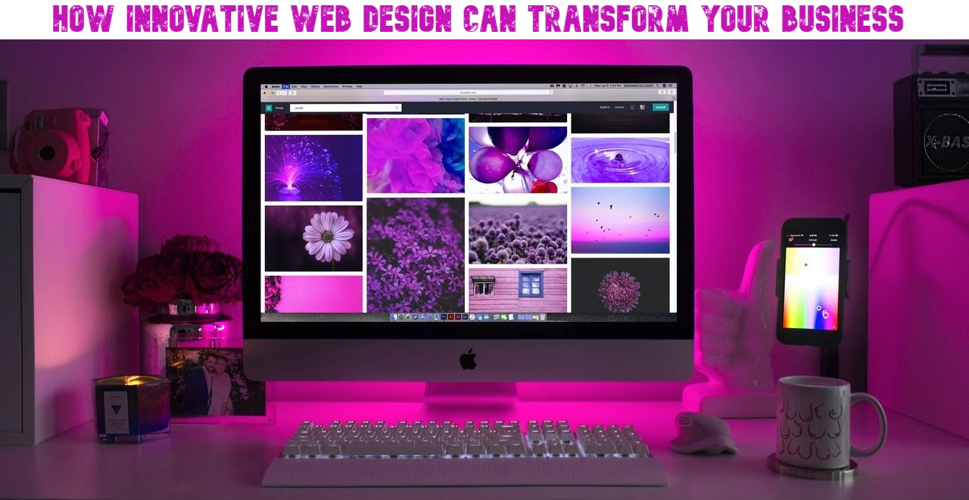

In the digital age, a website is often the first point of interaction between a business and its potential customers. Innovative web design can play a pivotal role in transforming a business by enhancing user experience, reinforcing brand identity, and driving engagement and conversions. Here’s how:

**1. Enhancing User Experience**

A well-designed website prioritizes the user experience (UX), making it easy for visitors to navigate and find the information they need. Innovative web design incorporates intuitive navigation, fast loading times, and responsive design to ensure a seamless experience across all devices. According to a study by Google, 53% of mobile users abandon sites that take longer than three seconds to load. Therefore, optimizing page speed and ensuring mobile compatibility are crucial for retaining visitors and reducing bounce rates.

By focusing on UX, businesses can create websites that not only attract but also retain users, turning them into loyal customers. Features like interactive elements, personalized content, and streamlined checkout processes can significantly enhance the user journey, leading to higher satisfaction and increased sales.

**2. Reinforcing Brand Identity**

Your website is a digital representation of your brand. Innovative web design allows businesses to showcase their unique identity through visual aesthetics, typography, color schemes, and overall layout. Consistent branding across all touchpoints, including your website, builds trust and recognition among your audience.

A distinctive and cohesive design can set your business apart from competitors. By integrating storytelling elements and visual cues that resonate with your target audience, you can create a memorable brand experience. This not only attracts new customers but also fosters brand loyalty, as customers are more likely to return to a website that they find visually appealing and trustworthy.

**3. Driving Engagement and Conversions**

Innovative web design goes beyond aesthetics to include functionalities that enhance user interaction and engagement. Features such as live chat support, interactive product displays, and social media [branding Newport](https://thewebdesignercardiff.co.uk/web-design-newport/) integration can significantly increase user engagement. Interactive elements not only make the website more dynamic but also provide users with a richer experience, encouraging them to spend more time on your site.

Additionally, incorporating clear call-to-actions (CTAs) and optimizing the user journey can lead to higher conversion rates. A well-designed website guides visitors through the sales funnel, from awareness to purchase, with minimal friction. According to HubSpot, a well-designed landing page can increase conversion rates by up to 200%.

**4. Facilitating Scalability and Adaptability**

As businesses grow, their websites need to evolve to accommodate new functionalities and content. Innovative web design ensures that your website is scalable and adaptable to changing business needs. Utilizing modular design principles and flexible content management systems (CMS) allows for easy updates and additions without compromising the site's performance or user experience.

Scalable web design is particularly important for e-commerce businesses, which may need to frequently update product listings, add new features, or integrate with third-party services. A scalable and adaptable website ensures that your business can continue to provide an excellent user experience, even as it grows and evolves.