**A Step-by-Step Guide to GMP Certification and Its Key Benefits**

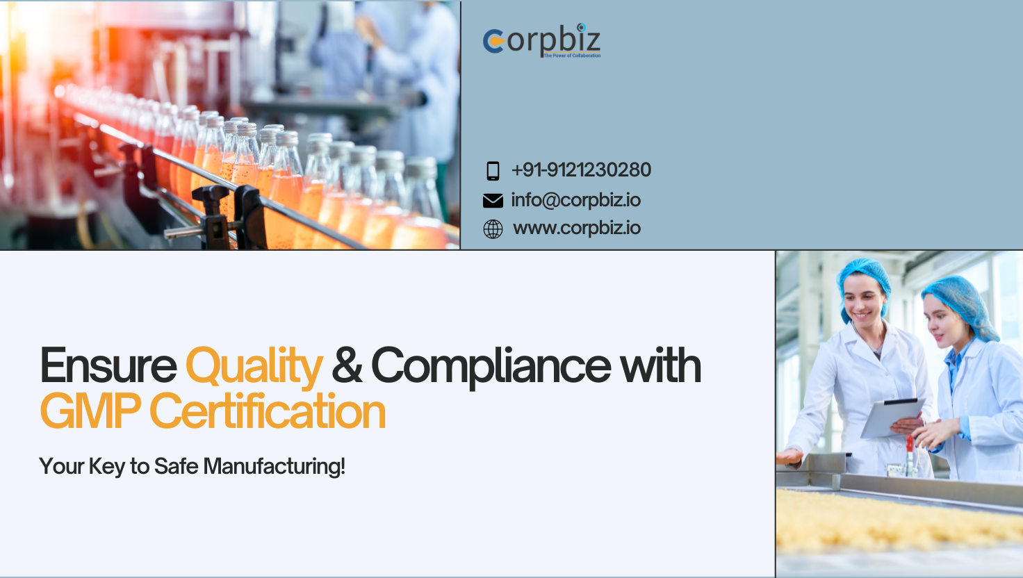

In today’s competitive market, maintaining quality standards is crucial for businesses involved in manufacturing. For companies in sectors like pharmaceuticals, food, and cosmetics, obtaining a GMP certification is essential to ensure product safety, quality, and compliance with regulations. In India, adhering to Good Manufacturing Practices (GMP) ensures that products are consistently produced and controlled according to quality standards. This guide will take you through the step-by-step process of obtaining GMP certification and highlight the key benefits it brings to your business.

**What is GMP Certification?**

GMP stands for Good Manufacturing Practices, a system that ensures that products are consistently produced and controlled according to quality standards. GMP is designed to minimize risks involved in any production process that cannot be eliminated through final product testing. It covers all aspects of production, from the starting materials, premises, and equipment to staff training and personal hygiene.

In India, GMP certification is mandatory for several industries, including pharmaceuticals, food processing, cosmetics, and supplements. A Good Manufacturing Practices Certificate demonstrates that a company follows the guidelines set forth by national and international regulatory bodies such as the World Health Organization (WHO) and the Indian government’s regulatory authority for specific industries.

**Why is GMP Certification Important?**

GMP certification ensures that products are safe, high-quality, and meet regulatory standards. It provides a framework for manufacturers to produce goods that consistently meet the required quality. Without GMP certification, businesses risk producing substandard products, which can result in consumer health hazards, regulatory fines, and reputational damage.

**Step-by-Step Process to Obtain GMP Certification in India**

Obtaining a Good Manufacturing License requires strict adherence to a step-by-step process. Here is how you can achieve GMP certification for your business in India:

**Step 1: Understand the GMP Guidelines for Your Industry**

The first step in obtaining GMP certification is to familiarize yourself with the specific Good Manufacturing Practices guidelines that apply to your industry. In India, different sectors like pharmaceuticals, food, cosmetics, and supplements have specific GMP regulations. For example:

* **Pharmaceuticals**: Indian companies must adhere to the Schedule M of the Drugs and Cosmetics Act.
* **Food processing**: Must comply with the Food Safety and Standards Authority of India (FSSAI) regulations.
* **Cosmetics**: Must comply with the Bureau of Indian Standards (BIS) and the Drugs and Cosmetics Act.

Understanding the detailed requirements specific to your business ensures that you’re fully prepared to meet the necessary standards.

**Step 2: Conduct a Gap Analysis**

Before applying for a Good Manufacturing Practices Certificate, it’s essential to conduct a thorough gap analysis to identify areas where your current manufacturing practices may fall short of GMP standards. The gap analysis will help you evaluate your:

* **Premises and equipment**: Are they in accordance with GMP standards?
* **Standard Operating Procedures (SOPs)**: Do you have detailed SOPs for each critical process?
* **Documentation and record-keeping**: Is your record-keeping system well-organized and transparent?
* **Training programs**: Are your employees well-trained on GMP guidelines?

A comprehensive gap analysis ensures that you can address any shortcomings before applying for certification.

Also Read: [**How to Start an LED Bulb Manufacturing Business?**](https://corpbiz.io/learning/how-to-start-an-led-bulb-manufacturing-business/)

**Step 3: Implement Necessary Changes**

Once the gap analysis is complete, the next step is to address any identified gaps in your processes. This could involve upgrading your equipment, revising your SOPs, implementing better hygiene practices, and ensuring that your staff is adequately trained.

Implementation of Good Manufacturing Practices should be an ongoing process where you strive for continuous improvement. Make sure your manufacturing process is in line with the guidelines set by Indian regulatory authorities.

**Step 4: Documentation and Record Keeping**

Proper documentation and record-keeping are critical components of GMP certification. Your business should have clear and detailed records of every aspect of the manufacturing process, including:

* **Batch records**: Documentation of each product batch from start to finish.
* **Training logs**: Proof that all employees have undergone GMP training.
* **SOPs**: Written Standard Operating Procedures for every critical aspect of production.
* **Calibration and maintenance records**: For equipment used in production.

Accurate and transparent records make it easier for inspectors to verify compliance with GMP standards.

**Step 5: Apply for GMP Certificate Registration**

Once you have ensured that all processes meet GMP standards, the next step is to apply for GMP certificate registration. In India, you will need to submit an application to the regulatory authority that governs your industry. For example:

* **Pharmaceuticals**: Apply to the Central Drugs Standard Control Organization (CDSCO) under the Ministry of Health and Family Welfare.
* **Food Processing**: Apply to the FSSAI.
* **Cosmetics**: Apply to the Bureau of Indian Standards (BIS).

The application will typically require submitting detailed documentation of your manufacturing processes, SOPs, and premises.

**Step 6: Inspection and Audit**

After submitting your application, the relevant regulatory body will schedule an on-site inspection to assess whether your facility complies with GMP standards. The inspection will involve:

* Reviewing your documentation and record-keeping practices.
* Checking the cleanliness and hygiene of your facility.
* Verifying that your equipment is well-maintained and calibrated.
* Ensuring that your employees are following proper SOPs.

If any deficiencies are found, you will need to address them and undergo a re-inspection.

**Step 7: Obtain the GMP Certificate**

If your facility passes the inspection and audit, you will be granted a [**Good Manufacturing Certificate**](https://corpbiz.io/gmp-certification). This certificate confirms that your business adheres to GMP standards, which ensures the safety, quality, and efficacy of the products you manufacture.

**Key Benefits of GMP Certification**

**1. Regulatory Compliance**

Obtaining a Good Manufacturing Practices Certificate ensures that your business complies with Indian and international regulations. Regulatory bodies frequently update their guidelines, and maintaining GMP certification ensures that your business stays up-to-date with current laws and standards.

**2. Improved Product Quality**

GMP certification guarantees that your products are consistently high in quality. Following GMP guidelines reduces the chances of errors or contamination during the manufacturing process. This is especially important in industries like pharmaceuticals and food, where product quality directly impacts consumer health.

**3. Enhanced Consumer Trust**

Consumers are becoming more discerning about the products they purchase, especially when it comes to health and safety. A GMP certification signals to consumers that your products have been manufactured under strict quality controls, which can increase consumer confidence in your brand.

**4. Access to New Markets**

Many countries require GMP certification for imported products. If your business is interested in expanding into international markets, having a Good Manufacturing License can open up new opportunities for growth. It also makes your products eligible for sale in countries where GMP compliance is mandatory.

**5. Risk Mitigation**

GMP certification helps to mitigate risks associated with manufacturing, such as contamination, mislabelling, or substandard products. By adhering to Good Manufacturing Practices, you minimize the chances of product recalls, legal issues, or reputational damage.

**FAQs**

**1. Is GMP certification mandatory in India?**

Yes, GMP certification is mandatory for specific industries in India, including pharmaceuticals, food processing, and cosmetics. It ensures that businesses comply with regulatory standards and produce high-quality products.

**2. How long does the GMP certification process take?**

The time to obtain GMP certification can vary depending on the readiness of your facility and the complexity of your manufacturing processes. Typically, the process can take anywhere from a few weeks to several months, including inspections and audits.

**3. What is the cost of obtaining GMP certification in India?**

The cost of obtaining a Good Manufacturing Practices Certificate varies depending on factors like the size of the facility, the industry, and the improvements needed to comply with GMP standards. Costs can range from ₹50,000 to ₹2,00,000 or more, including fees for inspections and audits.

**Conclusion**

Obtaining GMP Certification is a critical step for businesses involved in the manufacturing of pharmaceuticals, food, and cosmetics in India. Not only does it ensure regulatory compliance, but it also enhances product quality, consumer trust, and access to new markets. By following the step-by-step process outlined above, you can secure a Good Manufacturing License and reap the numerous benefits of operating a GMP-certified business.

**Source:** [**https://postr.yruz.one/a-step-by-step-guide-to-gmp-certification-and-its-key-benefits**](https://postr.yruz.one/a-step-by-step-guide-to-gmp-certification-and-its-key-benefits)

For more information related to **GMP Certification**, please contact us at info@corpbiz.io or call us at +91-9121230280.