Bill Nordmark, President and CEO
As President and CEO of Enlace Health, Bill Nordmark leverages over 20 years of healthcare expertise, always driving the company to be a forward-thinking, solutions organization that addresses the complex value-based care ecosystem. He is the visionary behind all areas of the business and leads the company’s growth efforts. Bill focuses on revolutionizing the healthcare industry, so that better care is provided at a lower cost. Recognized as a top 50 Healthcare Technology CEO of 2020, he leads from the frontlines and knows the importance of meeting all participants – payers, providers, and partners – in their respective worlds. Previously, Nordmark was the Chief Growth Officer for Payspan, a leading provider of electronic healthcare payments. Under his leadership, the company experienced record-breaking success. Nordmark balances his role as President and CEO with being a husband, father of two, and Vice Chairman of the Board of Representatives at the ALS Association.
D. Scott Foster, Chief Financial Officer
As Chief Financial Officer, Scott Foster drives financial oversight and provides critical insights into payer and provider networks and contracts. Scott brings over thirty years of healthcare experience working with leading insurance and healthcare organizations. Foster began his career at Ernst & Young and has served on the executive teams of Anthem, Centene, Piedmont-Wellstar, and WellCare. His extensive background in healthcare, from both payer and provider views, provides a true understanding and clear perspective on solutions needed to make value-based healthcare a powerful and successful initiative in healthcare.

Andy Williams, Chief Technology Officer
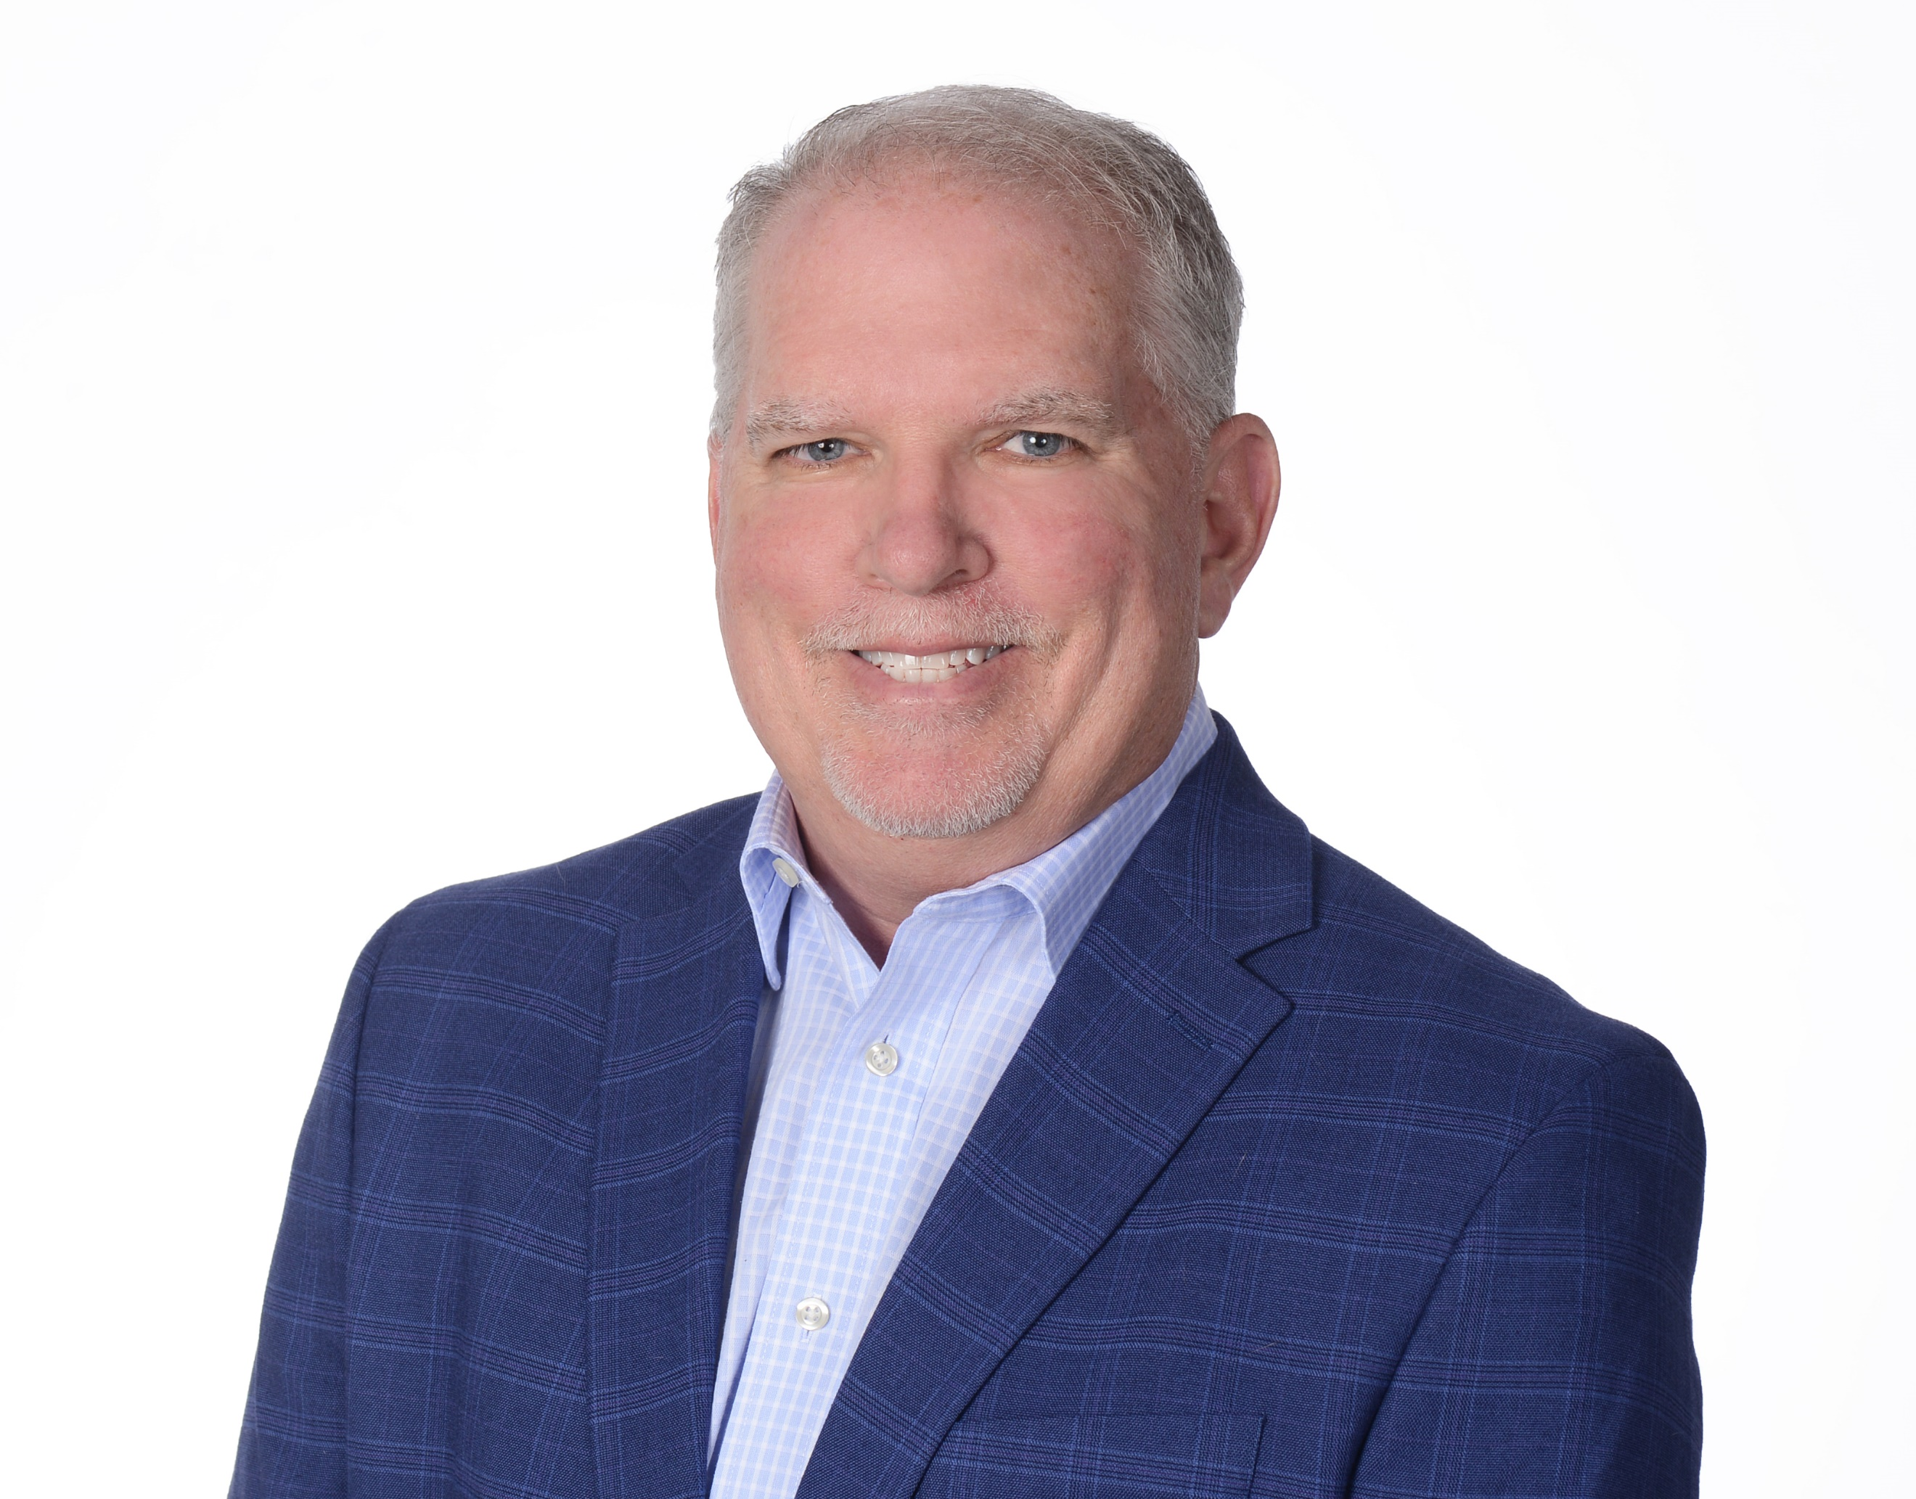
Andy Williams joined Enlace Health, bringing decades of technology expertise and passion. Andy has led the development of fast-growing technology focused companies. Prior to joining Enlace, Williams was the founder and CEO of Enablus, a UX strategy, design, and development agency. With a career that spans across many industries, including financial services, healthcare (physical therapy), global travel, and technology, Andy brings depth and breadth of technology knowledge.
Prior to Enablus, Williams had senior leadership positions at American Express and Carlson Travel, leading international teams in product development and marketing.

Robert Ball, Chief Privacy Officer & General Counsel
Robert serves as General Counsel and Chief Privacy Officer at Enlace Health, where he manages all legal, regulatory, privacy compliance and legislative policy matters. Prior to Enlace Health, Robert was the Chief Legal Officer and EVP of Corporate and Business Development at Ionic Security, where among other things he oversaw Ionic’s sale to Twilio, Inc. (NYSE: TWLO) in April of 2021.
Previously, Robert was a partner at Eversheds Sutherland and a member of the firm’s Cybersecurity & Privacy team. Prior to Sutherland, Robert was a senior executive at Akamai Technologies (NASDAQ: AKAM) in Cambridge, MA. As General Counsel, he managed Akamai’s initial public offering and oversaw all aspects of its corporate legal affairs. He joined Akamai after having been a partner at Alston & Bird, LLP where he co-founded the firm’s Internet & E-commerce practice group.

Amanda Allen, Chief Human Resources Officer
Amanda Allen serves as the Chief Human Resources Officer for Enlace Health. In her role, Amanda is responsible for leading overall human resources operations, culture enablement, talent acquisition, compensation and benefits, and employee relations. Amanda also leads Enlace’s comprehensive team strategy, including Diversity, Equity, Inclusion and Belonging, organizational design and development.
Amanda has more than 25 years of experience in human resources, partnering with leaders in various environments in the US and internationally. She has successfully leveraged human capital to improve business performance in managed care, health insurance, financial services, manufacturing, and within the nationalized health services (NHS) in the United Kingdom.

